Creating a git repo and initializing it with a ReadME.md

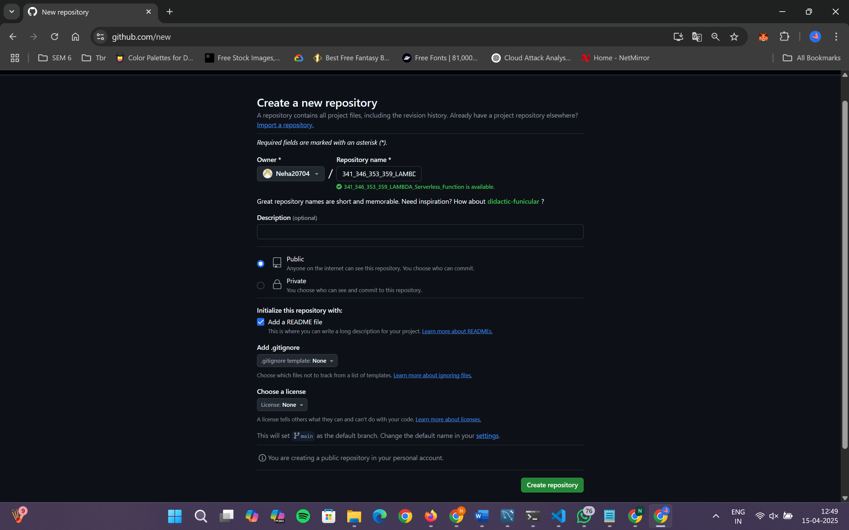

0.2: Clone and Initialize Project Structure

Run the following commands:

